Khuzema Asim

21L-7644

Section 8A

**Task 1:**

Approach to solve this problem:

· **Fetch Page** Used requests to get the HTML.

· **Parse Content** Used BeautifulSoup to extract data.

· **Extract Info** Name<span class="highlight"> ,Introductory text<p> and Social Media Links used this loop: for link in soup.find_all('a', href=True):

·

Fidings:

Page fetched successfully.  
Name, intro text, and social links were found.

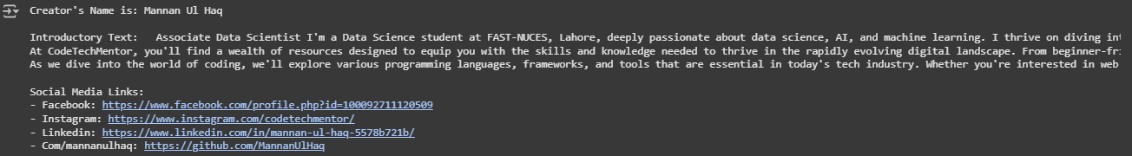

**Task 2:**

Approach to solve this problem:

· **Fetch Page** Used requests to get HTML.

· **Parse Content** Used BeautifulSoup to extract data.

· **Extract Info** Tablets names<'div', class_='p-title bold h5'>,Price<'div', class_='price-box p1'>,Discounts<'div', class_='price-diff-saving'>,Discontinued Products<'a', class_='fadeProduct>

· **Handle Missing Data** Skipped missing or unavailable details.

Fidings:

Page fetched successfully.  
 Tablet names, prices, and discounts extracted.

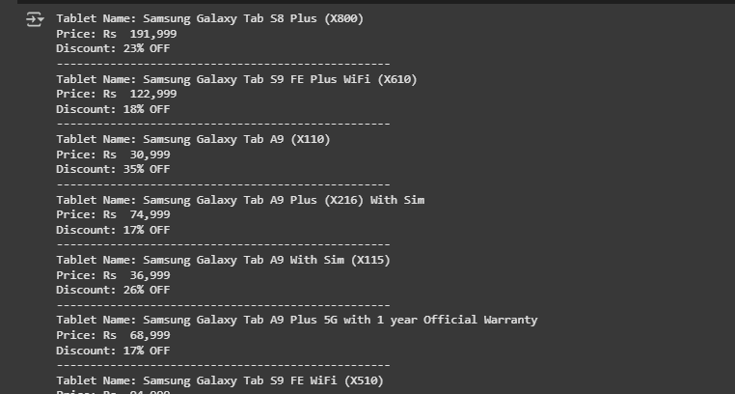

**Task 3:**

Approach to solve this problem:

· **Use Selenium** Navigate through the first 5 pages.

· **Parse HTML** Use BeautifulSoup to extract property details.

· **Extracted Data** **Location(by applying tags as shown in above tasks), Price, Beds, Baths, Area** from listing elements.

· **Store in DataFrame** Organize extracted data for analysis

Fidings:

Successfully extracted property details.  
 Data formatted into a structured table.

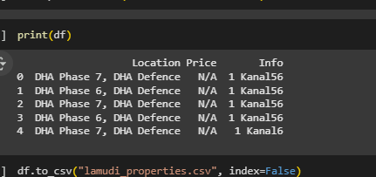

**Task 4:**

Approach to solve this problem:

**Install dependencies** (selenium, webdriver-manager, pandas).

· **Set up ChromeDriver** in Google Colab.

· **Use Selenium to navigate Yahoo Finance.**

· **Extract and store data in a pandas DataFrame.**